Multisectoral EWAR Bottleneck-Enabler Tool
This multi-sectoral activity supports the identification of bottlenecks and enablers associated with an event that involves multiple health sectors. Outcomes will result in focused recommendations to help improve the timeliness and process completion of event-based surveillance (EBS) and early warning, alert, and response (EWAR) systems -- both within a specific health sector, as well as across multiple health sectors. In addition, this tool helps assess if signals emerging from the environment, animal population, or at international travel/trade pathways were (or could be) detected early enough to prevent or mitigate impacts further downstream (e.g. on human populations). Example events that can be evaluated by this tool include:
- Wildlife die-offs
- Livestock disease outbreaks
- Vector expansion or increases
- Cross-border disease importations
- Ill travelers detected at ports of entry
- Contaminated imported food or goods
- Zoonotic pathogen spillover
- Antimicrobial resistance
- Chemical or radiological hazards
- Environmental contamination
- Climate-driven disasters

Figure 1: Example Epidemic Curve of an Outbreak Impacting Multiple Health Sectors
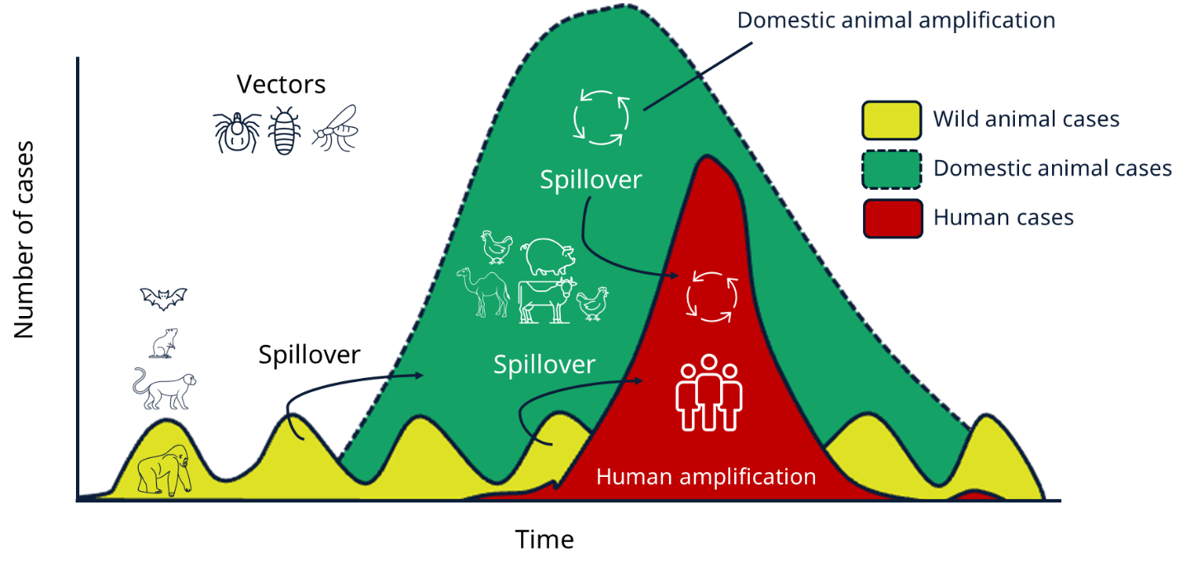
Bottlenecks and enablers are factors that prevent or facilitate timely action during an event. That is, bottlenecks delay action and enablers acceleration action. To identify these factors, individuals directly involved in the initial detection, reporting and response to a particular event should be gathered as part of this activity. Depending upon the event assessed, participants can include representatives from the following sectors:

- Ministry of Public Health
- Ministry of Agriculture / Veterinary Services / Wildlife Services
- Environmental Health Agencies
- Border Health / Port Health Authorities
- Immigration / Customs
- Laboratories
- Emergency Response Units
- NGOs and/or International Partners

Identified bottlenecks and enablers may be technical, operational, or political. When identifying bottlenecks, ensure that each is specific, clearly described and linked to its root causes so that it can be effectively addressed through future system improvements. Examples of clear bottlenecks by category are provided below in Table 1.

Table 1: Example Bottleneck Categories
Categories | Example Bottlenecks
Staffing | Shortage in staff numbers and inadequate training
Coordination | Lack of contact numbers to enable coordination among ministry of health and partners
Data Systems | Faulty information system not recording data, lack of interoperability, lack of electronic data system, incomplete surveillance data
Event Characteristics | Site access issues, new or unexpected pathogen, wide-spread and poorly characterized event
Patient & Community | Delay in care-seeking by patient, community members unaware of hotline number
Planning & Procedures | Lack of adherence to SOPs and EWAR procedures
Policy | Delayed approvals, lack of government policy & regulations
Resources & Procurement | Lack of funding, inadequate supplies, power outage
Environmental | No wildlife surveillance system, Environmental data not linked to health systems, Veterinary and public health databases not interoperable, No formal cross-sector reporting protocols, Delays in laboratory confirmation
Border Health/Points of Entry | Lack of health screening at ports of entry, Limited communication between border and public health agencies, No SOP for reporting ill travelers, Delays in international information sharing

Table 2 lists different bottleneck categories and examples and was adopted from the 7-1-7 Alliance; enablers would just be the opposite of bottlenecks in this example. A consolidated table of identified bottlenecks and enablers can be found in Annex A.

Table 2: Characteristics of a Clear Bottleneck
Characteristics of a Clear Bottleneck | Unclear Bottleneck | Clear Bottleneck
- Phrased in specific, concrete, measurable, and observable terms  - Describes the exact delay/gap observed  - Identifies the underlying root cause of an observed delay  - Focuses on systems, processes, or structure issues and avoids individual blame or complaints  - Linked to a specific step of the EBS/EWAR process  - Is actionable, something that can realistically be addressed | “Shortage of staff”  Why it is unclear:  • Too vague  • Doesn’t specify where the shortage occurred  • Doesn’t explain how the shortage caused delay  • No identifiable root cause  • Not actionable without additional detail | “It took 2 days for the community health worker supervisor to review and triage all the signals reported by the community due to having only one trained staff member assigned to the task and a minimum of two assigned staff members are needed.”

The multisectoral tool is organized with timeliness indicators and bottleneck/enabler questions at each step. During the activity participants will record the critical dates associated with each step (by each sector involved) to help calculate the associated timeliness.

Figure 2: Suggested Timepoints for the EBS/EWAR Steps
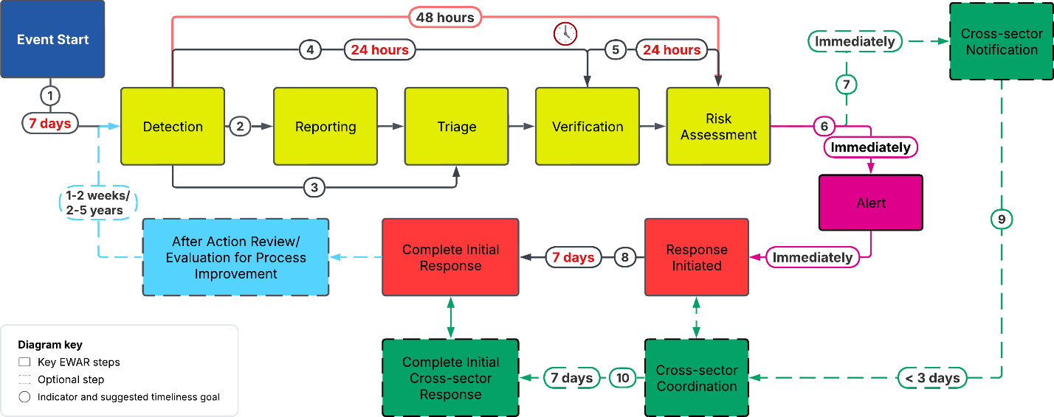
*Note: Monitoring occurs throughout the whole process.

Cross-sector notification, coordination, and response are critical in a multisectoral pathway. Once a signal has been reported, triaged, and verified, information needs to be shared across to the other relevant sectors that are (or could be) impacted. The earlier an event like this is detected and responded to, the more likely preventative measures can be put in place to prevent or decrease the impact on the downstream health sectors. Additionally, coordination across sectors during the response phase could result in more economical, collaborative, and streamlined approaches - especially regarding the dissemination of clear, transparent, and consistent risk communication.

Figure 3A. Multisectoral Reporting Pathway

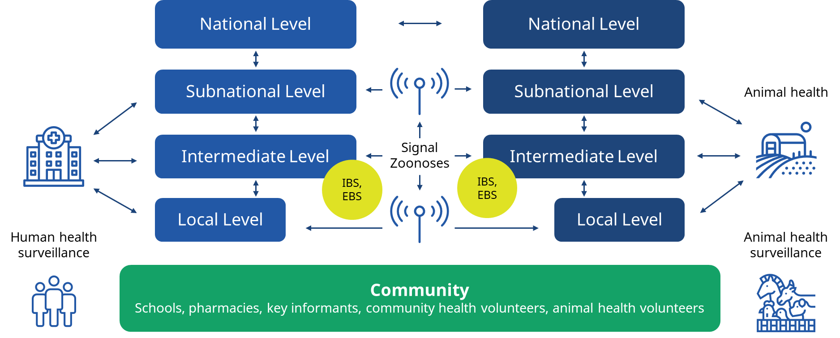

Figure 3B. Multisectoral Reporting Pathway

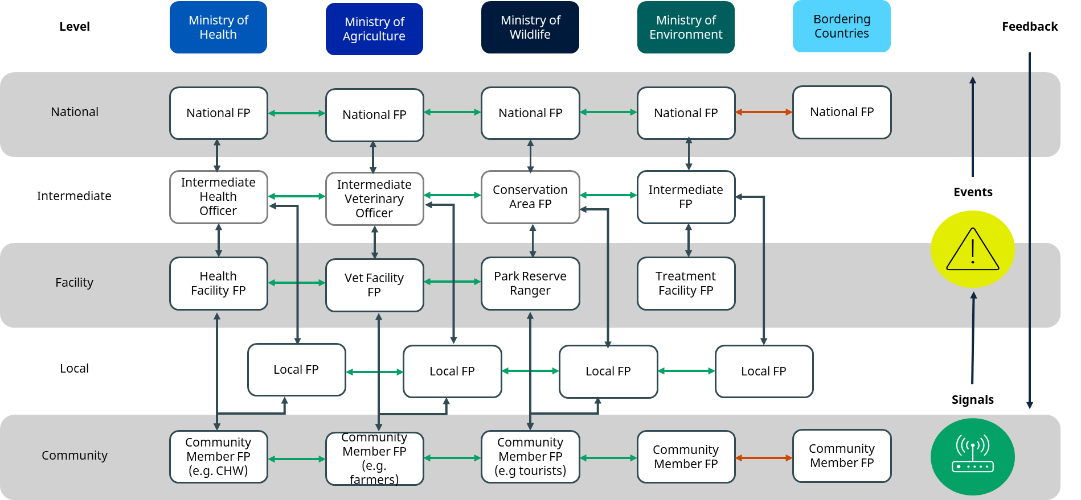

Figure 4: Example Epidemic Curve when EWAR has Effectively Prevented/Mitigated Down-stream Impacts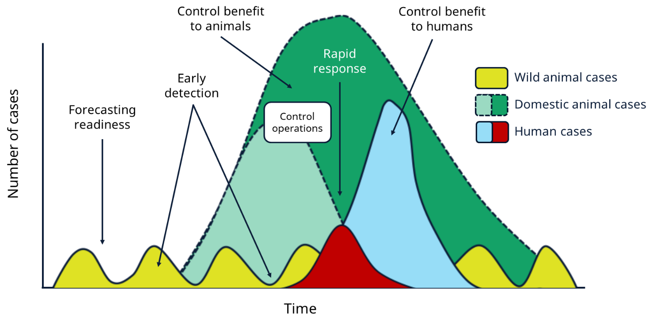

Event Name: ______________________________ Event Location: ______________________ Today’s Date: __________________
Sectors Involved (check all that apply): ☐ Animal health ☐ Border/Port Health ☐ Environmental Health
☐ Public Health ☐ Other (specify): ______________________________________

Step 1: Record EBS/EWAR Process Dates (MM/DD/YYYY) by Sector Involved
EWAR Steps | Environment | Animal | Border Health | Public Health | Other | Narrative (How was the date determined?)
Event Start
Detection
Reporting
Triage
Verification
Risk Assessment
Alert
Cross-sector notification*
Response Start
Cross-sector coordination and response*
Initial response completion
Key: * = when one sector (i.e., human, animal, environment) officially contacts, coordinates, or responds with a different sector

Step 2: Calculate the Timeliness Intervals by Sector

Indicator | Time Taken (in days) by Sector |  |  |  |  | Suggested Time | Target Met?  (yes/no/partially)
 | Environment | Animal | Border | Public Health | Other
- Timely Detection  (Detection - Event Start) |  |  |  |  |  | 7 days
- Timely Reporting  (Reporting - Detection) |  |  |  |  |  | <1 day
- Timely Triage  (Triage - Detection) |  |  |  |  |  | <1 day
- Timely Verification  (Verification - Detection) |  |  |  |  |  | 1 day
- Timely Risk Assessment  (Risk Assessment - Verification) |  |  |  |  |  | 1 day
- Timely Alert  (Alert – Risk Assessment) |  |  |  |  |  | <1 day
- Timely Cross-sector Notification  (Cross-sector Notification - Risk Assessment or Verification) |  |  |  |  |  | <1 day
- Timely Response  (Initial Response Completion - Response Start) |  |  |  |  |  | 7 days
- Timely Cross-sector Coordination*  (Cross-sector Coordination - Cross-sector Notification) |  |  |  |  |  | 2-3 days
- Timely Cross-sector Response  (Initial Response Completion - Cross-sector Coordination) |  |  |  |  |  | 7 days

Step 3. EBS/EWAR Bottleneck and Enabler Discussion Questions by EBS/EWAR Step
Below are the questions that you can ask at each step of the EBS/EWAR process to get an understanding of the bottleneck and enablers. This section asks about the event context in relation to each step and can be helpful background to discuss prior to listing bottlenecks and enablers. These should be followed for each sector participating in the multisectoral event.
Question | Answer (Provide as much detail as possible)
Detection
Where did the initial signal for this event come from? How was this reported and from where? E.g. source & geographical location
Are there any unique features where the event came from? E.g. remote area, high-density, refugee population
How was this signal detected? Explain the process, modality, and note if this is the typical way that signals are detected.
Where was this signal recorded? Paper form/electronic system and is this the typical way signals are recorded?
What were the next steps that took place after this signal was detected?
Triage
Explain how this signal was triaged. Is this the typical process taken for triage?
Which signal did this signal match with in the country’s national signal list?
What were the next steps that took place after this signal was triaged?
Verification
Explain how this signal was verified. Is this the typical process taken for verification?
What were the next steps that took place after this signal was verified as an event?
Risk Assessment
Explain how the rapid risk assessment was conducted for this event? Is this the typical process?
What tool was used and what was the outcome? Does your tool include an assessment of hazard, exposure, context?
Did you gain new information about the event after conducting the initial rapid risk assessment? If yes, was the risk assessment updated?
What were the next steps that took place after the rapid risk assessment?
Alert
Explain how the alert was issued for this event? Who and how were they contacted? Was the process automated? Did this reflect the typical alert process?
What were the next steps that took place after the alert was issued?
Cross-Sector Notification
How was information shared between sectors?
Were there clear protocols for cross-sector reporting?
Did this process occur before or after verification? Before or after risk assessment?
Response
Explain how the event was initially responded to? What were the immediate actions taken? Did this reflect the typical response process?
How long did the response take overall before the event was declared closed? What were the most impactful response actions that led to the control of the event?
Cross-Sector Coordination/Response
Was there a formal multisectoral or multisectoral coordination mechanism?
Did laboratories support both human and animal testing?
Were joint investigations conducted?
Did environmental, animal, or border health surveillance provide an early warning before human cases occurred?
If yes, identify the sector(s) that provided an early warning before human cases occurred (i.e., environment, animal, border health, etc.). What was the lead time before human detection?
If no, what barriers prevented earlier detection?

Step 4: Compile the bottleneck and enablers identified at each interval.
These should be followed for each sector participating in the multisectoral event.
Interval | Bottlenecks  Factors that prevented timely action. | Enablers  Factors that enabled timely action.
Detection
Triage
Verification
Risk Assessment
Alert
Cross-sector Notification
Response
Cross-sector Coordination and Response

Step 5: Identify action items to help improve the EBS/EWAR system
Based on the ideal situation, how would you improve your EBS/EWAR workflow to ensure timely response? Identify the priority action items that should be taken in the short-term (less than 6 months).
Interval | Action Items | Lead Agency / Person responsible for leading change efforts? | Target Implementation Date (MM/DD/YYYY)
Detection | 1.  2.  3.
Triage
Verification
Risk Assessment
Alert
Cross-sector Notification
Response
Cross-sector Coordination and Response

Glossary
Date of Event Start (synonym: Date of Emergence): defined by the Thirteenth General Programme of Work (GPW13), the ideal date is the date of the index case’s symptom onset. Alternative measures could include symptom-onset date of first reported case (=initial case); first visit to health-care facility; suspected primary case; most likely exposure date (estimated); first exposure date (estimated); latest exposure date (estimated); outbreak start date; date of death of first reported case (=initial case); first report of the outbreak. 7-1-7 further elaborated that for endemic diseases this is the date on which a predetermined increase in case incidence over baseline rates occurred; for non-endemic diseases this is the date on which the index case or first epidemiologically linked case first experienced symptoms; and for other public health events this is the date the threat first met criteria as a reportable event based on country reporting standards

Date of Event Detection: defined by the GPW13, the ideal date is the date local health authorities detect the event. Alternative dates to consider include, first confirmatory laboratory test; first sample collection date; Ministry of Health (MoH) press release date; rapid diagnostic test (RDT) date; first time diagnosed as suspected case; date other external party reported to MoH; date outbreak declared; date local health authority reported to MoH; preliminary laboratory test; communication from laboratory to MoH; date first communication between third party Member States happened; and date local health authority detected signal through media.

Date of (First) Report: earliest date that a detected signal is reported into a surveillance system or to a surveillance staff. Depending on the surveillance modality this could be done by the same person and at the same time that a signal is detected (e.g. detecting and logging a media report) or by different people (e.g. a community health worker reporting a detected signal to their supervisor). Reporting is something that can also happen multiple times when information is escalated up a reporting chain. This can also be interpreted by some as a form of notification; however, in terms of 717, alert may be a better synonym for notification. (see Date of Alert and Date of Notification)

Date of Triage: earliest date that the process of triage (i.e. screening the data and information that are relevant for early detection purposes) occurs. Triage screens out mild/irrelevant events from potential acute public health events, as well as eliminates duplicates and corrects obvious mistakes.

Date of Verification: earliest date that verification (i.e. the proactive assessment by EWAR of the validity of the signals collected) occurs. Verification eliminates hoaxes, false rumours and artefacts. This may involve contacting the primary source or additional sources, or performing field investigations.

Date of Risk Assessment: earliest date that a risk assessment occurs – in this context this is typically referring to as a rapid risk assessment that needs to be conducted prior to alert being issued. A risk assessment is a systematic process of gathering, assessing and documenting information to assign a level of risk (risk characterization) to human health from an acute public health event, and to inform actions to manage and reduce the negative consequences of events.

Date of Alert (or Notification): earliest date that an alert (or notification) is issued to the team responsible for response actions to an event. An alert is a public health signal that has been i) verified to be an event; ii) risk assessed; and iii) requires an intervention (an investigation, a response or a communication with partners or the public). (see Date of Report and Date of Notification)

Date of Notification: according to 7-1-7, this is the date the event is first reported to a public health authority responsible for action. (see Date of Report and Date of Alert)

Date of Cross-sector Notification: when one sector (e.g., human, animal, environment) officially contacts a different sector about an event.

Date of Event Response Start: earliest date of any public health intervention to control the event including the date the field investigation started; incident management system set up; vaccination campaign started; active surveillance initiated; rapid response team deployed; active surveillance initiated; risk communication started; date quarantine started; vector control campaign launched; food/product recall started; national emergency operation centre (EOC) activated; and expert group established.

Date of Cross-sector Coordination and Response: when multiple sectors (e.g., human, animal, environment, etc.) officially initiates a coordinated response to a shared event.

Date Initial Response Completed: according to 7-1-7, this is the date on which all applicable early response actions were completed including, initiating an investigation or deploying a response team; conducting an epidemiologic analysis of burden, severity and risk factors; obtaining laboratory confirmation of the outbreak etiology; initiating appropriate case management and infection prevention and control (IPC) measures; initiating appropriate public health countermeasures in affected communities; initiating appropriate risk communication and community engagement activities; and establishing a coordination mechanism.

See the 7-1-7 Alliance materials.
See the 7-1-7 Alliance materials for more information on initial response activities. These include staff deployment for an initial investigation, laboratory diagnosis, EOC activation, establishing risk communication and clinical management protocols.
See the “Bottleneck-Enabler Focus Group Calculations” Excel Spreadsheet to help simplify calculations.
World Health Organization Rapid Risk Assessment of Acute Public Health Events has further details on questions to ask about hazard, exposure, and context.
See: THIRTEENTH GENERAL PROGRAMME OF WORK 2019–2023 (https://www.who.int/publications/i/item/WHO-PRP-18.1)

